**Ansible Dynamic Inventory**

Requirements for Dynamic Inventory:  
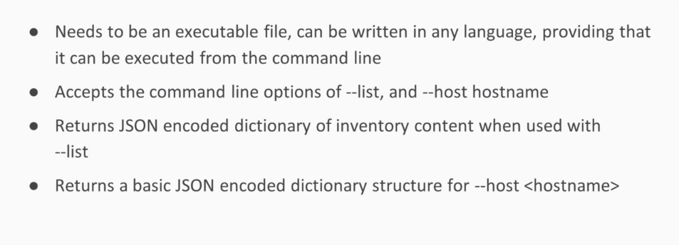

Passing dynamic inventory:  
ansible all -i inventory.py -m ping

Remember as long as inventory is in JSON output ansible will respect that else it will not.

Requirements mentioned above are hard and fast for dynamic inventory.

Mandatory Step:  
~ export AWS_ACCESS_KEY_ID=<your_aws_access_key_id>  
~ export AWS_SECRET_ACCESS_KEY=<your_aws_secret_access_key>

To get list of hosts:  
./ec2.py –list

To list hosts based on region:  
ansible -i ec2.py us-east-2c --list-hosts

To ping the hosts as per region:  
ansible -i ec2.py us-east-2c -m ping

To ping only the ec2 instances:  
ansible -i ec2.py ec2 -m ping

***Steps to enable Ansible management on Windows Machine:***

**Luckily Ansible community did that for us and just we need to run below steps:**

$url = "https://raw.githubusercontent.com/ansible/ansible/devel/examples/scripts/ConfigureRemotingForAnsible.ps1"

$file = "$env:temp\ConfigureRemotingForAnsible.ps1"

(New-Object -TypeName System.Net.WebClient).DownloadFile($url, $file)

powershell.exe -ExecutionPolicy ByPass -File $file

winrm enumerate winrm/config/Listener

$thumbprint = "32FCE13B7450C948CC6C1ACB7B392286ADD6FA22"

Get-ChildItem -Path cert:\LocalMachine\My -Recurse | Where-Object { $_.Thumbprint -eq $thumbprint } | Select-Object *

$selector_set = @{

Address = "*"

Transport = "HTTPS"

}

$value_set = @{

CertificateThumbprint = "32FCE13B7450C948CC6C1ACB7B392286ADD6FA22"

}

New-WSManInstance -ResourceURI "winrm/config/Listener" -SelectorSet $selector_set -ValueSet $value_set

winrm get winrm/config/Service

winrm get winrm/config/Winrs

For control Machine:

sudo apt-get install python-pip

pip install pywinrm

Some Important reference links:  
<https://www.virtualbox.org/wiki/Linux_Downloads> : for Linux Distributions of Oracle Virtual Box.

For Ansible Windows Modules:  
<https://docs.ansible.com/ansible/latest/modules/win_updates_module.html#win-updates-module>

For Dynamic Inventory:  
cd /etc/ansible >> sudo vi ec2.py >> chmod 777 ec2.py

<https://raw.githubusercontent.com/ansible/ansible/devel/contrib/inventory/cobbler.py>

sudo vi ec2.ini

<https://raw.githubusercontent.com/ansible/ansible/devel/contrib/inventory/ec2.ini>